Activity 1: Brainstorming
Level: Intermediate
Predictions about the year 2025

Activity steps
- The T introduces the topic : Consider that in 1900 it was fantastical to think that " we will use “correspondence cinema” (what we now call videoconferencing), we will genetically engineer a variety of foods, we will use interactive e-books in the classroom, air travelling will become a common means of transport, or laser surgery will be available to us.”

- The T asks the Ss to look at the following pictures and make predictions about them:
What will our planet be like in the future?
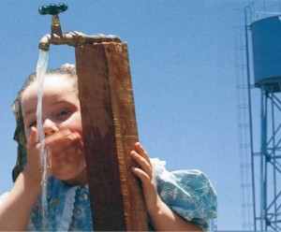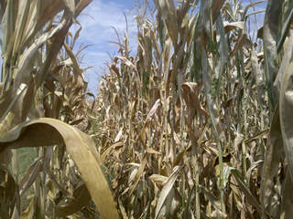
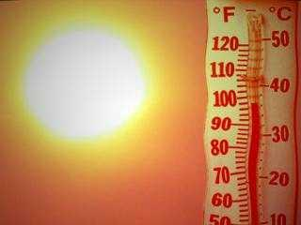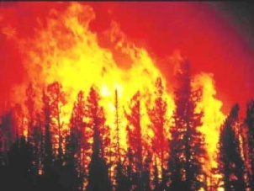

- The T asks the students to choose the prediction matching the picture:
a. Deserts will expand. a.Temperatures will rise. a.Drinking water will decrease.
b. Freshwater levels will fall. b.Deserts will expand. b.Deserts will expand.
c. Food supplies will decrease. c.Food supplies will decrease. c. Farmland will shrink.

a. Drinking water will decrease. a. Deserts will expand. a.Food will be a lot cheaper.
b. The planet will get colder. b.Drinking water levels will decrease. b.Farmland will shrink.
c.Farmland will shrink. c.Temperatures will rise. c.Wildlife will increase.

(Internet source: http://www.englishexercises.org/makeagame/viewgame.asp?id=7078)

- The T asks the Ss to suggest other predictions about what life will be like in the future and keeps a record of the Ss’s ideas on the blackboard (suggested fields: transport, medicine, school, endangered species, communication, technology).

What will be different in the future?

I think technology will give us new hobbies. For example, children won’t ride bikes because they’ll ride on hoverboards.
What will be different in the future?
People won’t need petrol because they’ll have solar cars.

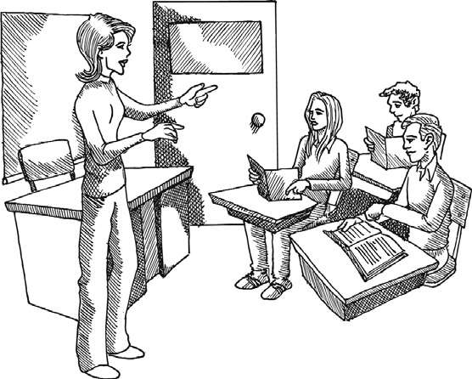
The air will be so polluted that we won’t be able to breathe it.
We won’t have cats or dogs because we’ll have virtual pets.

In my opinion robots will do the housework. Houses will have video-phones.

Language of agreeing and disagreeing
Asking for opinions | Agreeing |  | Disagreeing
What do you think?  Do you agree with me?  Do you know what I mean?  What about...? | I agree (with you/that).  You’re absolutely right. Yes, you’re right. |  |  | I don’t agree (with you/that). I’m afraid I disagree. That’s not the way I see it.  I don’t think that…  I’d prefer…  But what about…  The way I see it is that…

Expressing opinions and preferences:
I think..., I believe…, As far as I'm concerned..., I'm convinced that..., In my opinion...,
I'd rather..., I'd prefer..., The way I see it..., I suppose..., It is fairly certain that..., Without a doubt...

Giving reasons and offering explanations:
To start with…, The reason why..., That's why..., For this reason..., That's the reason why..., Considering...,

Activity 2: Observation
Level: Intermediate

Practising Second Conditional (rule induced)

Activity steps
- The T presents the new language in a meaningful context. I find that building up stories on the board, using realia or flashcards and miming are fun ways to present the language. The T uses a picture of herself with thought bubbles of lots of money, a sports car, a big house and a world map.
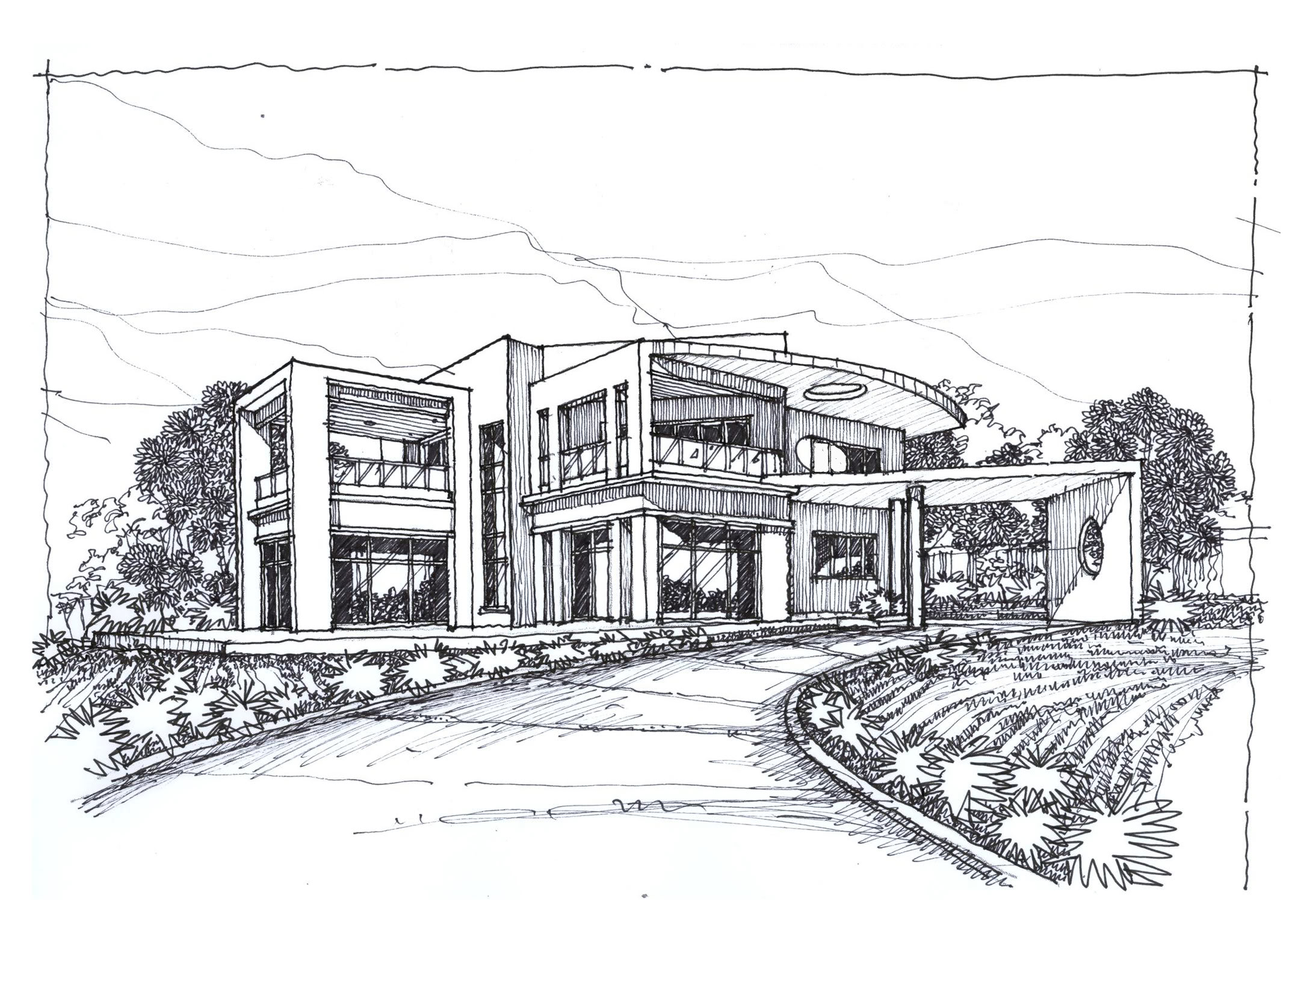
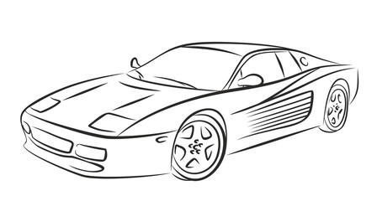

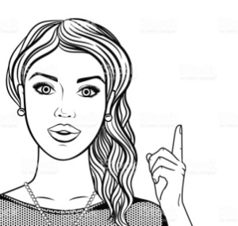

The T asks the Ss what she’s thinking about and then introduce the target
language:
"If I won the lottery, I would buy a sports car and a big house."
The T practises and drills the sentence orally before writing it on the board. She makes a few more sentences as students have only just met the new language.
- Then the T asks the Ss what they would do if they won the lottery and writes half of the sentence on the blackboard:
"If I won the lottery, I would...”
The T elicits answers through the class, dealing with any difficulties encountered by the students.
- The T gets individual Ss to say what they would do in each of the following situations:

8> Over to you.

Talk about these questions in pairs or groups.
- If your home caught fire, which three things would you save?
- If they decided to rebuild your school, what suggestions would you make for changes?
- If you were mayor, what improvements would you make to your local area?

(Snapshot Pre-Intermediate, Student’s book 54)
and offers constructive feedback rephrasing the sentences correctly when Ss have made mistakes.

